Application to be a Gig Buddy volunteer – 2022 Version
Hi there!
Thanks for being interested in being a Gig Buddy!
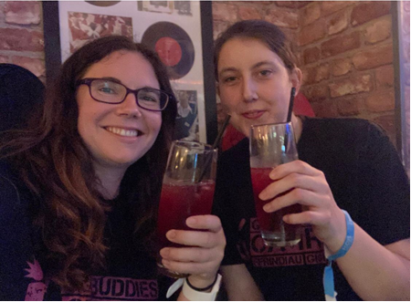
We have included below some information about volunteering as a Gig Buddy, and our project. If you are interested, please can you complete the attached application form and send it back to us.
If you have any questions, please let us know. Our contact details are at the end of this document, or you can ask us whatever you need to when we meet.
How Gig Buddies help to improve people’s lives
Many people with a learning disability find it difficult to go out and enjoy the things that they love to do. For example, almost 1 in 3 young people with a learning disability spend less than an hour a day outside their homes on an average Saturday (2016 Mencap research).
Barriers that prevent people going out, especially at night, include: lack of support, fear of bullying and discrimination, transport issues, confidence, nobody to go with, and not knowing what’s on.
By being a Gig Buddy you will play a really important part in supporting someone to overcome these issues.
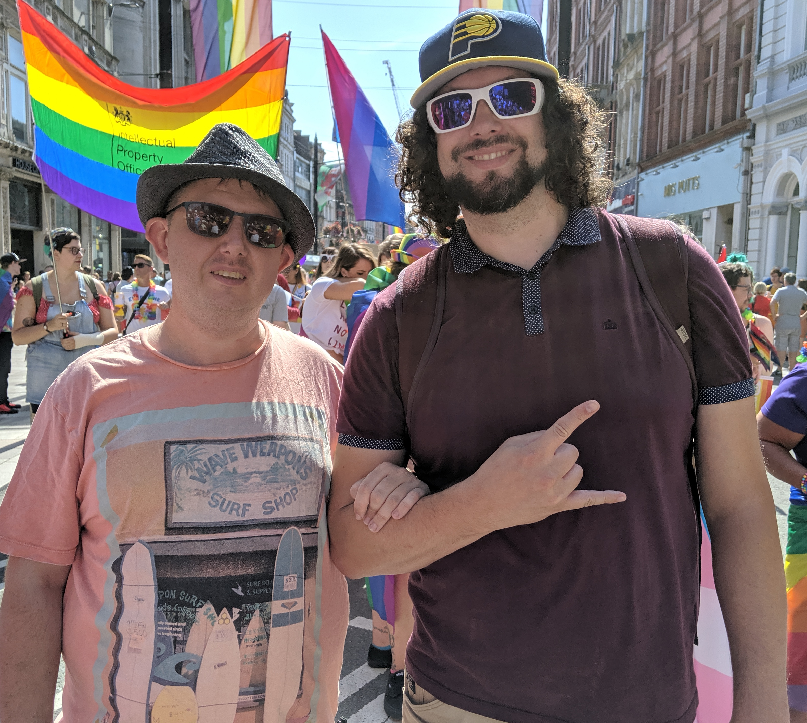
What happens next?
As soon as we receive your application we will arrange to meet you for an informal interview. This is so we can find out a little more about you and start to think about who you will make a great Gig Buddy for.
We will let you know when we think we have made a good match and will then arrange for you and your Gig Buddy to meet each other.
Meanwhile we will invite you to attend a free Gig Buddies training session. And we will process a DBS check for you (that we will pay for) – this is a police check that makes sure our Gig Buddies are safe to support vulnerable people.
Gig Buddies training
The free training covers all parts about being a great Gig Buddy, including:
- an introduction to learning disability and autism
- the barriers that people with a learning disability and autism face in life - and how having a Gig Buddy can help improve their lives
- communication
- safeguarding (keeping your Gig Buddy safe)
- tips for having a great time with your Gig Buddy.
What is expected of Gig Buddy volunteers?
We ask you and your Gig Buddy to attend, on average, 1 gig or event every month. We can support you and your Gig Buddy at your first gig together.
We also ask you to meet up with your Gig Buddy for a short meeting every month to plan your next gig. You can do this at a café or pub, or somewhere else that your Gig Buddy likes to go.
Every month we also hold Gig Buddies socials, where we invite all our Gig Buddies to get together for an event.
More information
Find out more about Gig Buddies on our website and social media: www.ldw.org.uk/gigbuddies
@FfrindiauGigiau
Email: gigbuddies@ldw.org.uk
Phone: 029 2068 1160 or 07506 902320
Our staff all work part time and will get back to you as soon as they can.
Kai, Kylie, Heather, Rachel, Danielle and Karen
Gig Buddies Cymru / Ffrindiau Gigiau Cymru
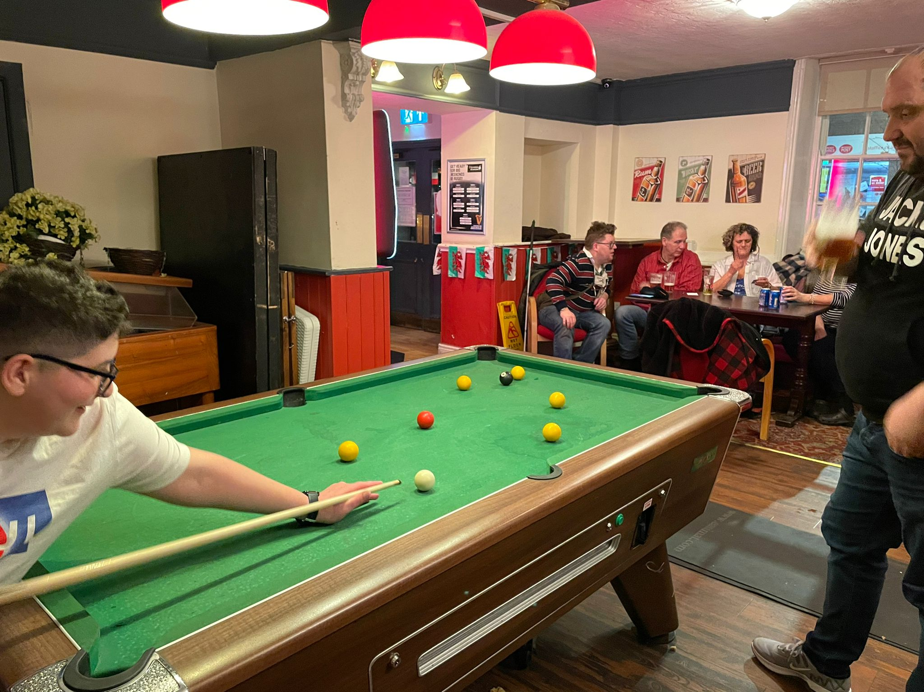

Application to volunteer for Gig Buddies Cymru

Please fill out the information on pages 4-6. Then make a profile about yourself on pages 7 and 8 – please make your language as accessible as possible on these pages.

Name
Address
Telephone (home and mobile)
Email
Date of birth
Do you have a driving licence and access to a car?
Are you willing to travel (either driving or public transport) in order to volunteer?
Do you have any health needs that we should be aware of? (please get in touch if you would like to discuss support that you will need to volunteer)
Please give us the name of an emergency contact for you | Name:  Relationship to you:  Telephone:  Address:
Are you happy for photos of yourself to be used to promote gig buddies? | Yes No
Please provide details of two referees that we can contact to confirm that you will make a great volunteer: one referee must know professionally, the other can be a friend (not family member). | Name:  Relationship to you:  Address:  Email:  Telephone:
Second referee | Name:  Relationship to you:  Address:  Email:  Telephone:
Criminal convictions
Gig Buddies has to make sure that all our volunteers are safe to work with people with a learning disability – all information you give will be treated confidentially.

All Gig Buddies volunteers will need to have a police check through the Disclosure and Barring Service before they can start.

If you have a conviction we will need to meet and talk about it, but it won’t necessarily prevent you from volunteering. We will only take into account a criminal record if it could be important to your role as a Gig Buddy.
Have you ever been convicted of any criminal offence by a court of law? | Yes No  (If yes please give details)
Please declare | As far as I know, all information that I have provided on this form is correct.  Name:  Date:  Please email or post this form to: gigbuddies@ldw.org.uk  Address: Gig Buddies Cymru, Learning Disability Wales, 41 Lambourne Crescent, Llanishen, Cardiff, CF14 5GG
All about (write your name here)
Please replace this picture of Elton John with a photo of yourself

I live in… | Write the name of your town
I am aged
Music I like | Tell us your favourite artists and genres – and anything you really don’t like.
My hobbies and interests | Please include any special skills you have, for example you teach a Zumba class or won awards for sports at school!
Experience of disability or people with a learning disability and/or autism | Please tell us if you what experience you have. For example, do you have any family members or friends who are disabled, or have you worked with disabled people or people with a learning disability.  Don’t worry if you don’t have any experience – you can still be a great Gig Buddy. This information is helpful when we start to think of who you would be a great Gig Buddy for.
Why I want to join gig buddies!

Why I would be a good gig buddy! | You could list your experience of working with or socialising with people with a Learning Disability and /or Autism, things you’re good at and / or your personal qualities (Don’t worry if you haven’t any ‘formal’ experience, you can still make an awesome Gig Buddy!)

